**Practical No. :- 10**

**AIM :-** Implement OpenNebula

1. Install Virtual Box
2. Choose the location where you want to install the Open Nebulla.
3. Click on Yes to proceed with the installation.
4. Click on Install to start the installation.
5. Your Oracle VM virtual box is installed successfully, now open it.
6. Welcome to VirtualBox page will open.
7. Click on add to add the new virtual machine.

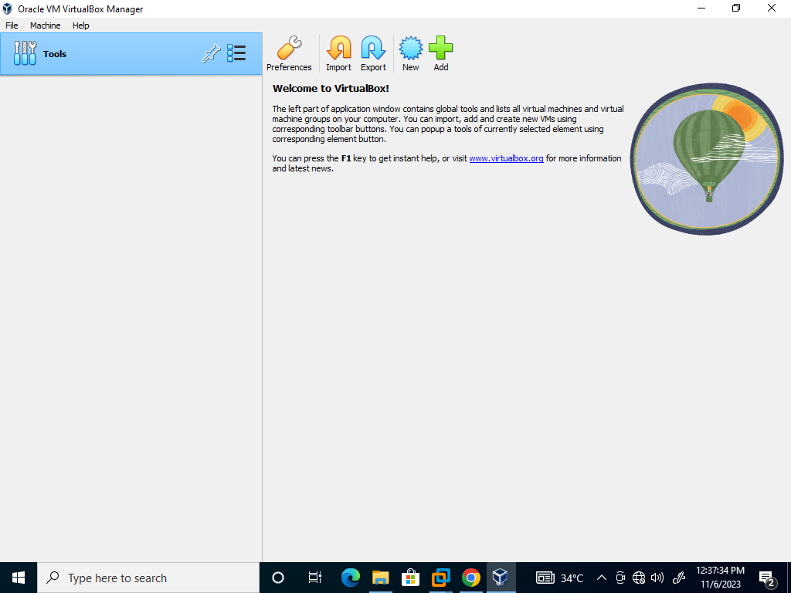

1. Enter the name and location of the virtual machine and OS and click on next

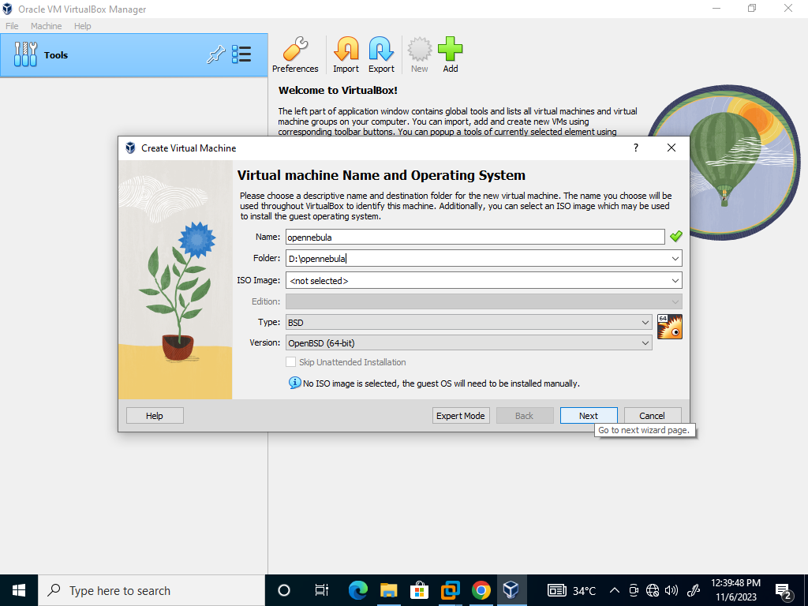

1. Set the Base Memory as 4GB and Processors as 2 and click on next.

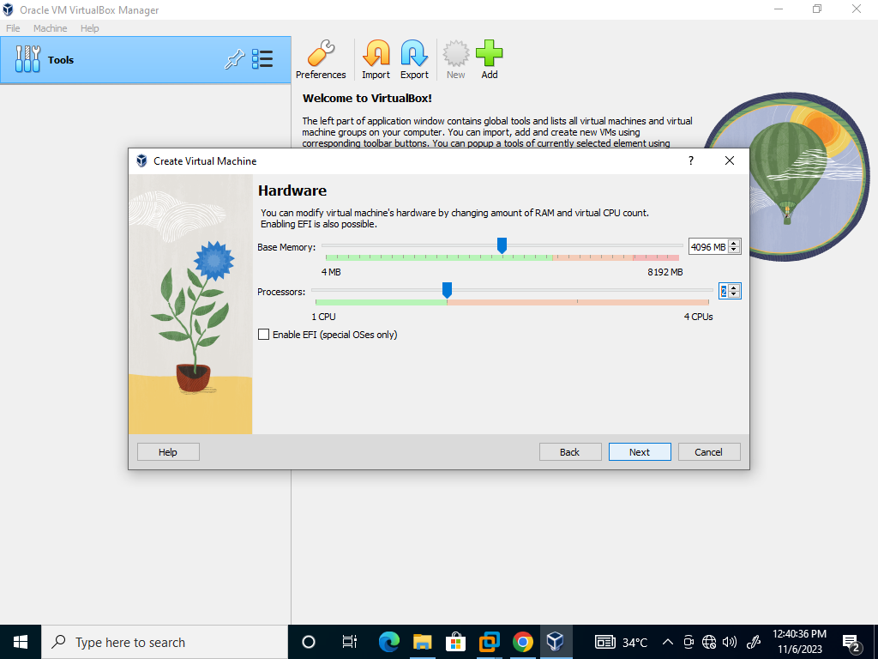

1. Select the location of opennebula, which you already have in the system.

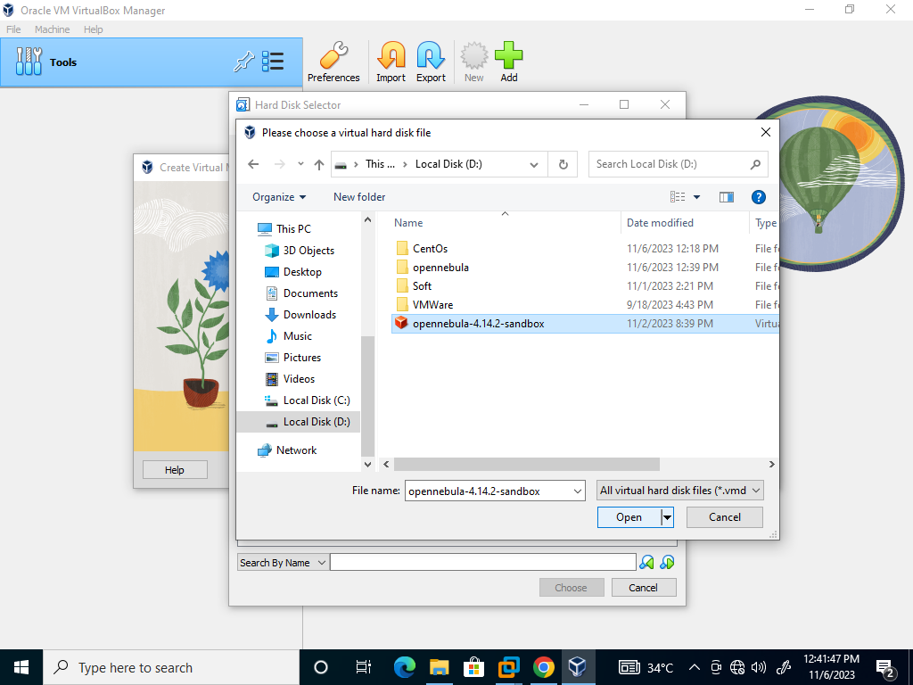

1. Now as the open nebula is selected from files, click on choose.

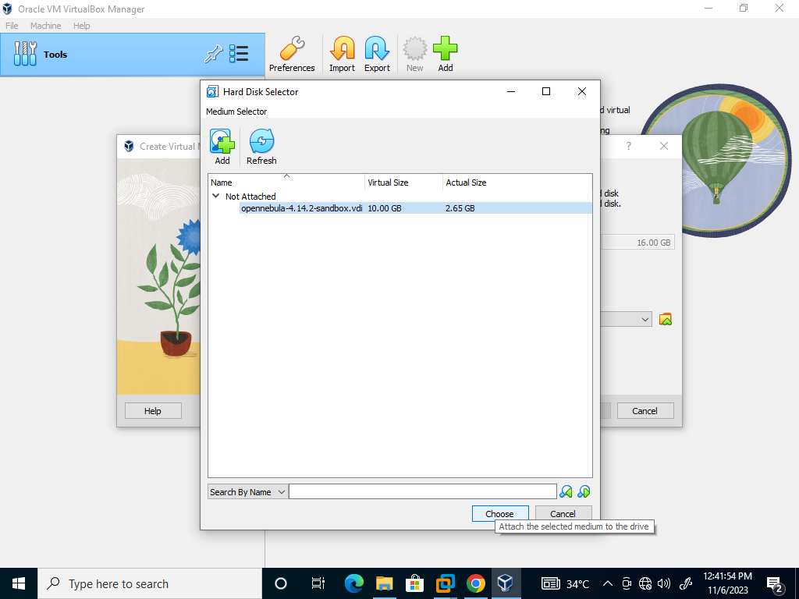

1. To choose the virtual hard disk click on use an existing virtual hard disk file.

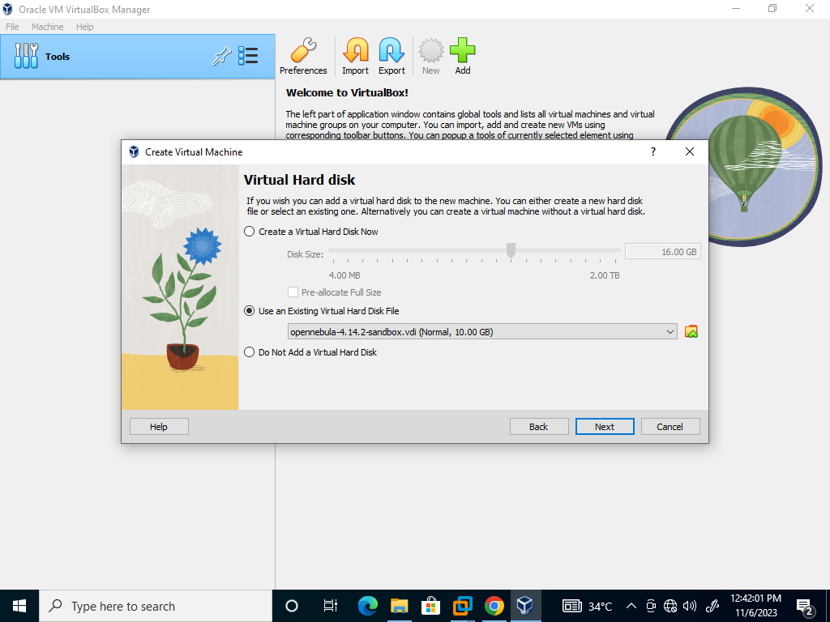

1. Now check the summary, weather all the options you have chosen are correct and click on finish.

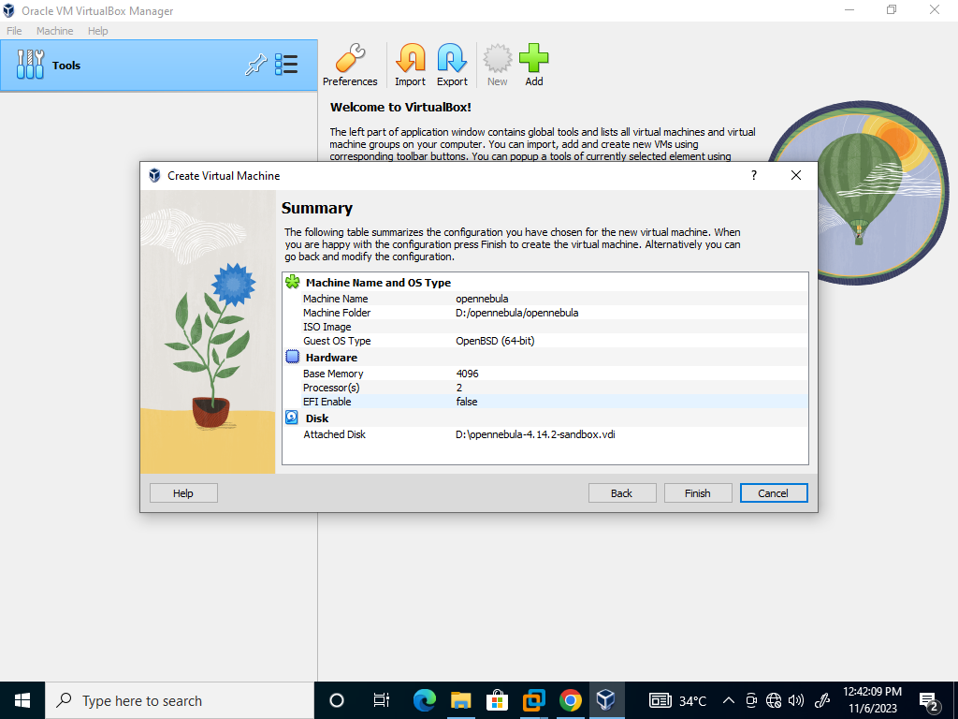

1. Click on start.

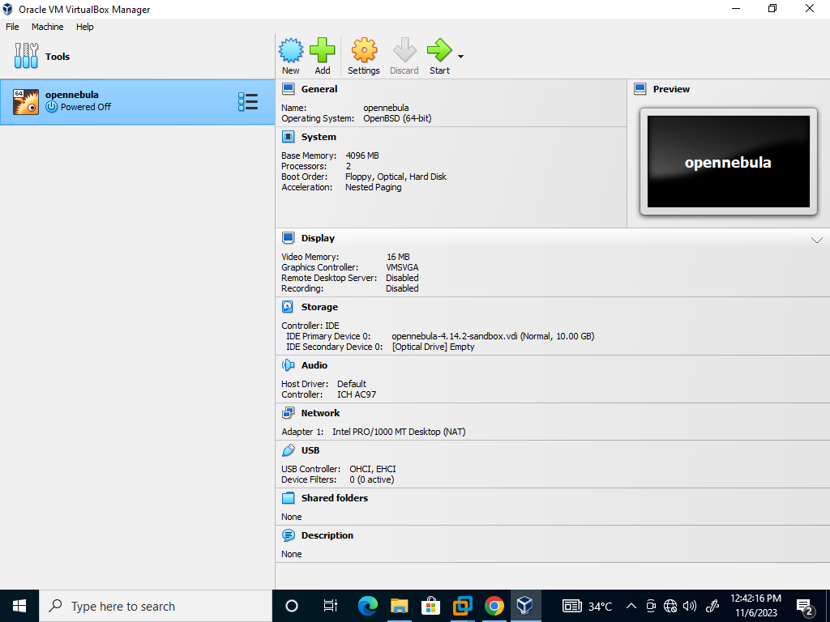

1. Powering of virtual machine.

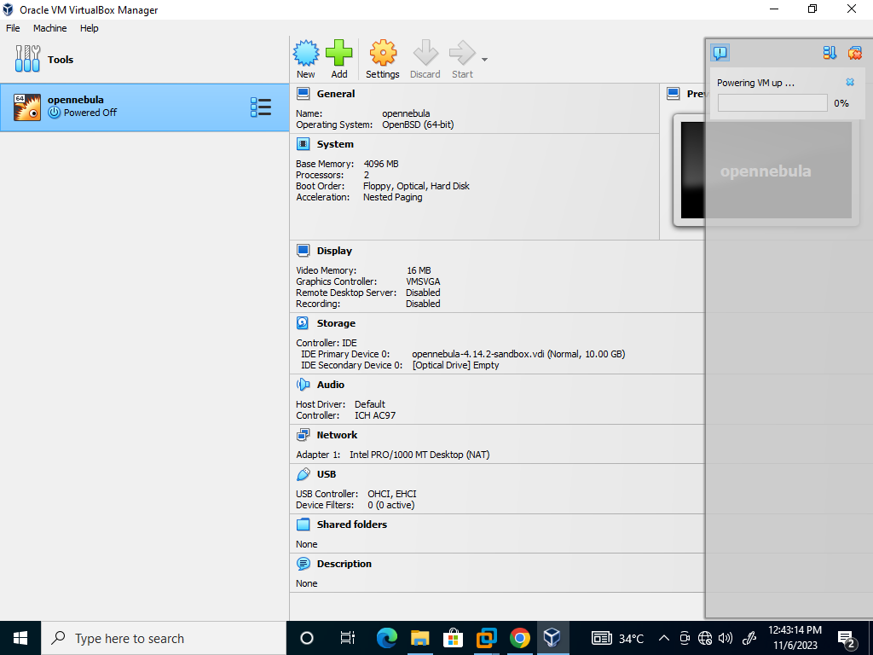

1. Opennebula Running.

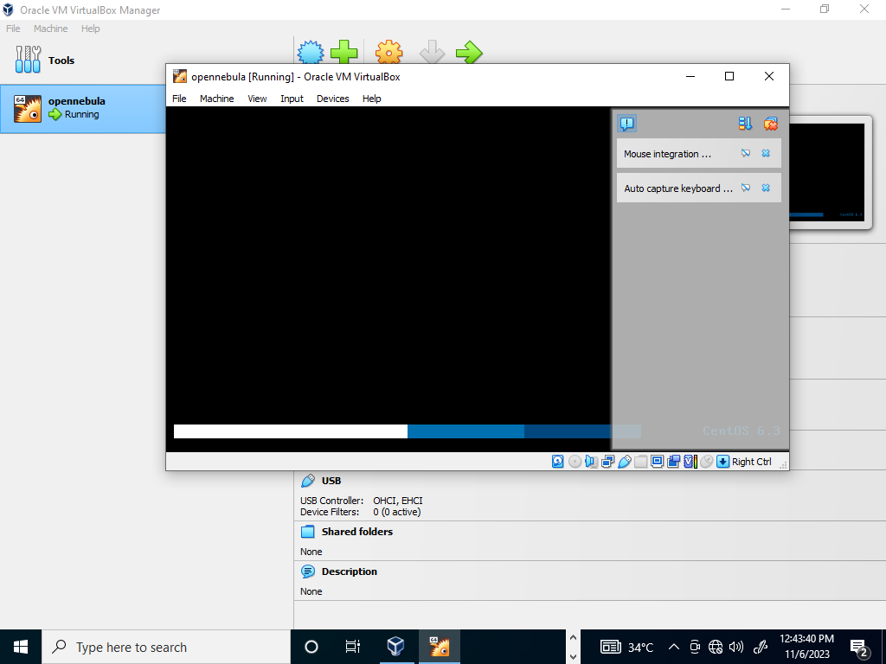

1. Enter one – sandbox Login as root and enter the password and click enter.

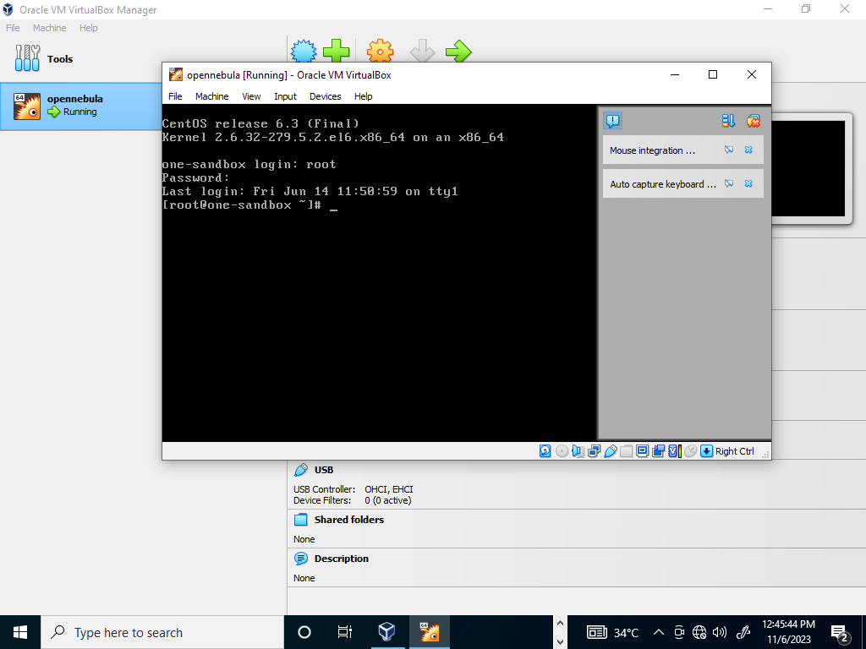

1. Scroll up and note the IP address.

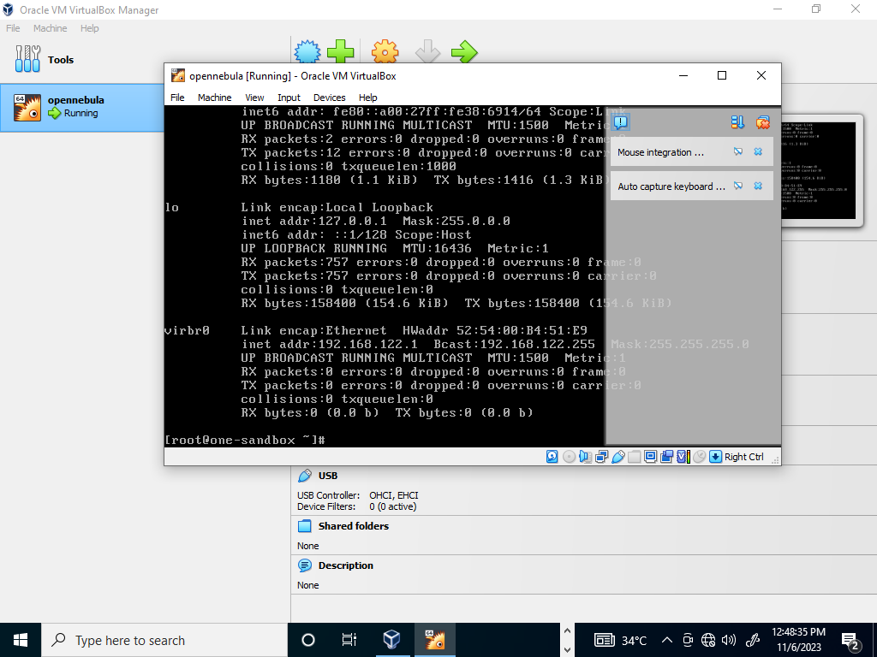

1. The IP address.

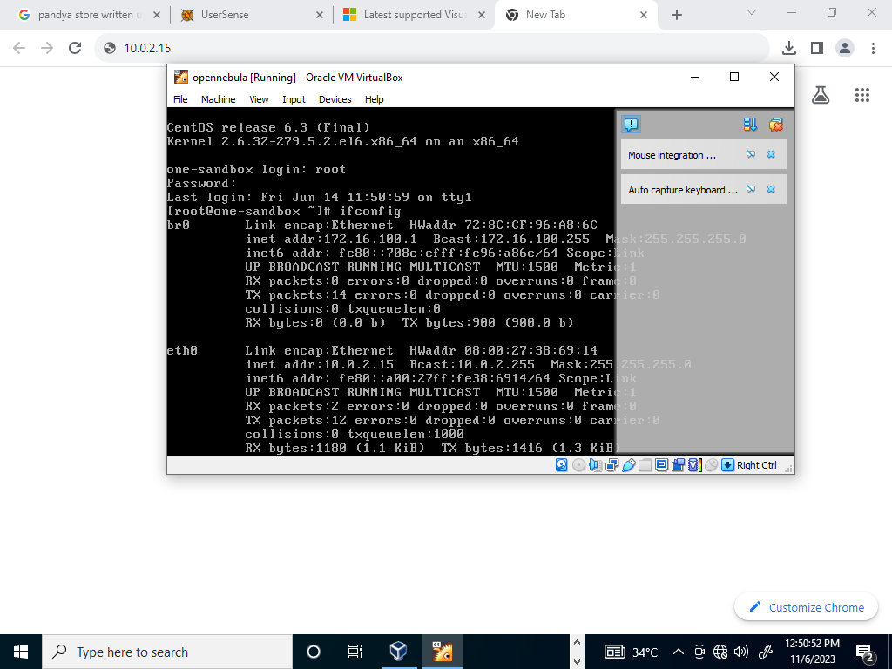

1. Enter the address on your Browser.

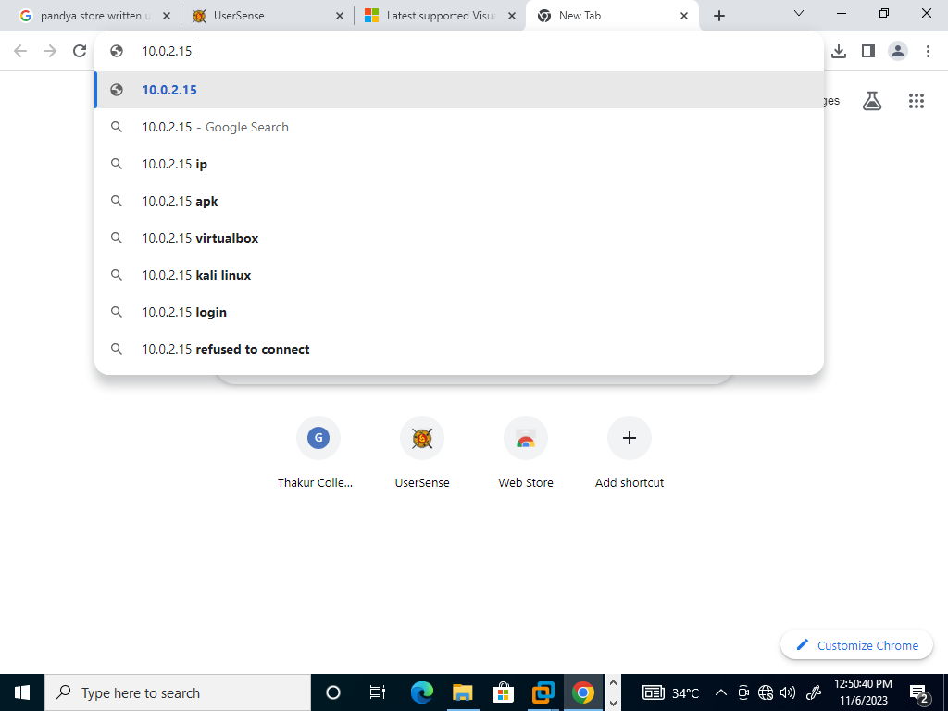

1. OpenNebula Sunstone UI will open, enter your username and password click on login.

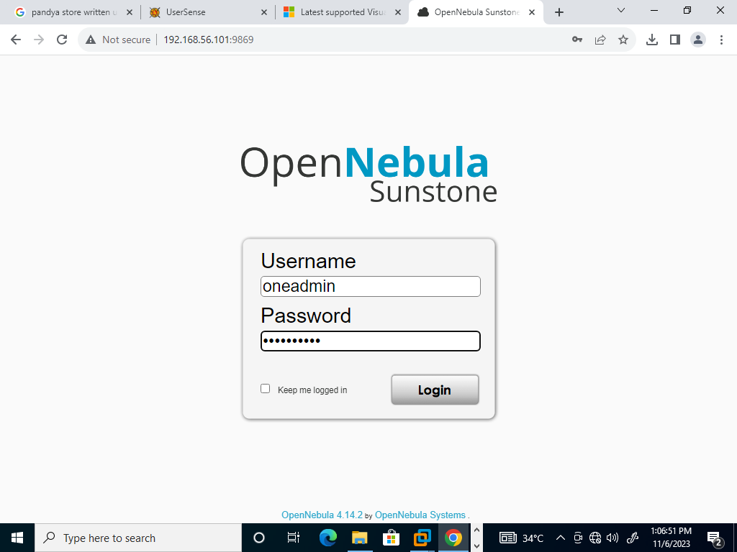

1. OpenNebula Dashboard click on bar beside OpenNebula

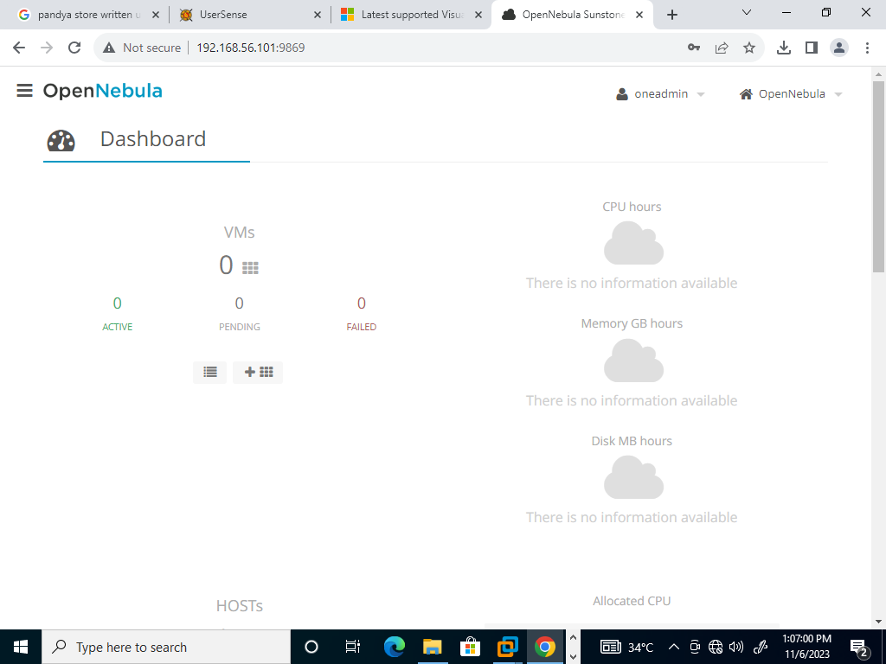

1. Click on create and click on 0 to add the admin information.

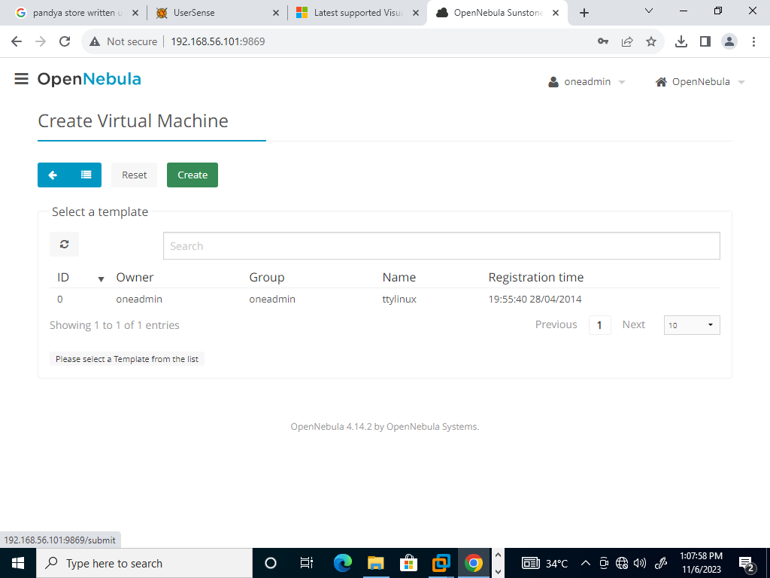

1. Set the Memory at 4 gb and CPU at 4.

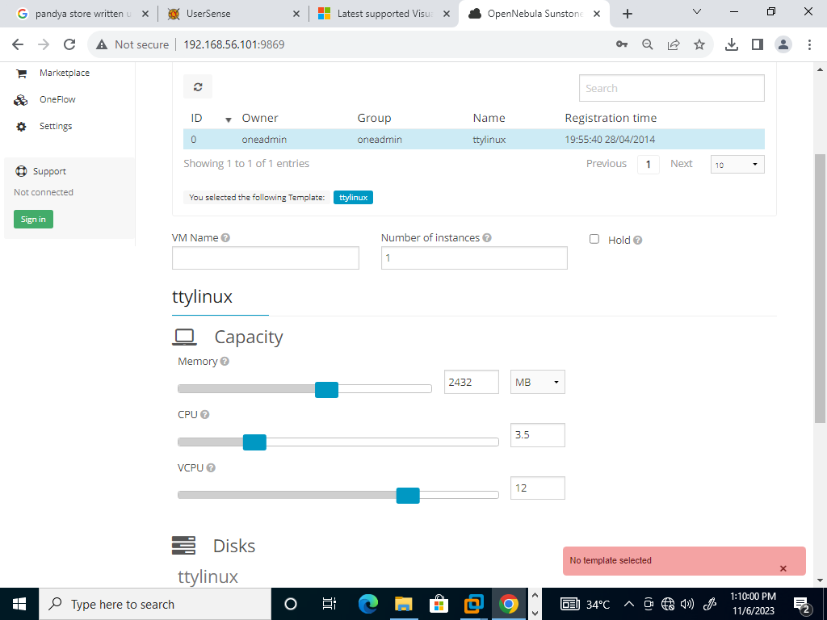

1. Press Enter.

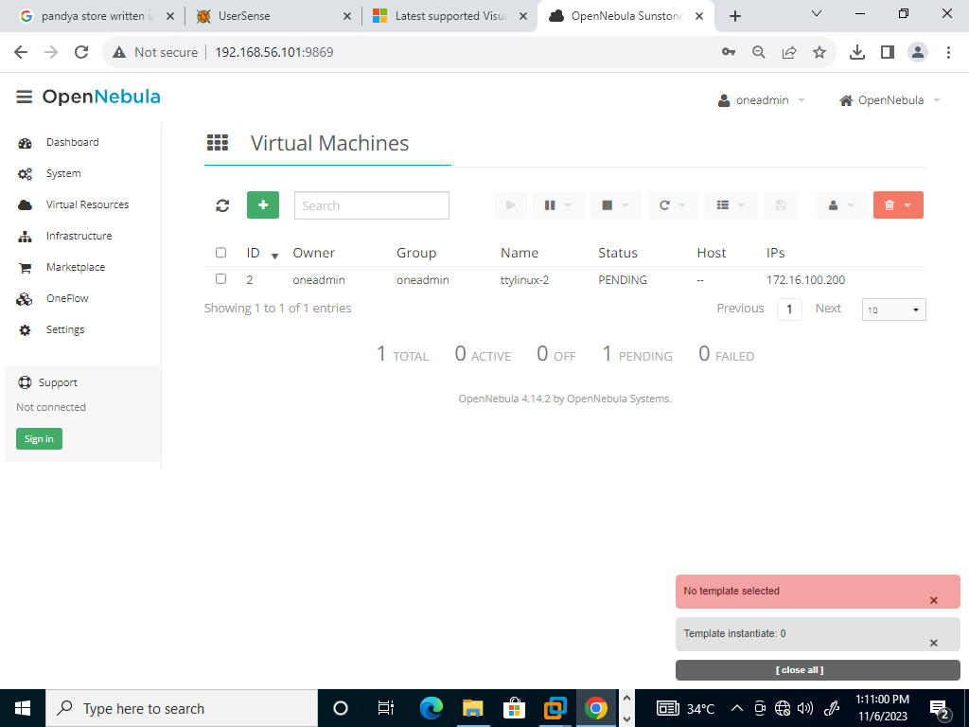

1. The Oneadmin has been created

